**Assignment 8.1**

**Problem Statement**

**1.Get a list of employees who receive a salary less than 100, compared to their immediate employee with higher salary in the same unit**

**Sol:**

SELECT name, salary, lead(salary)

OVER (PARTITION BY unit ORDER BY salary)

FROM users where salary <100 ;

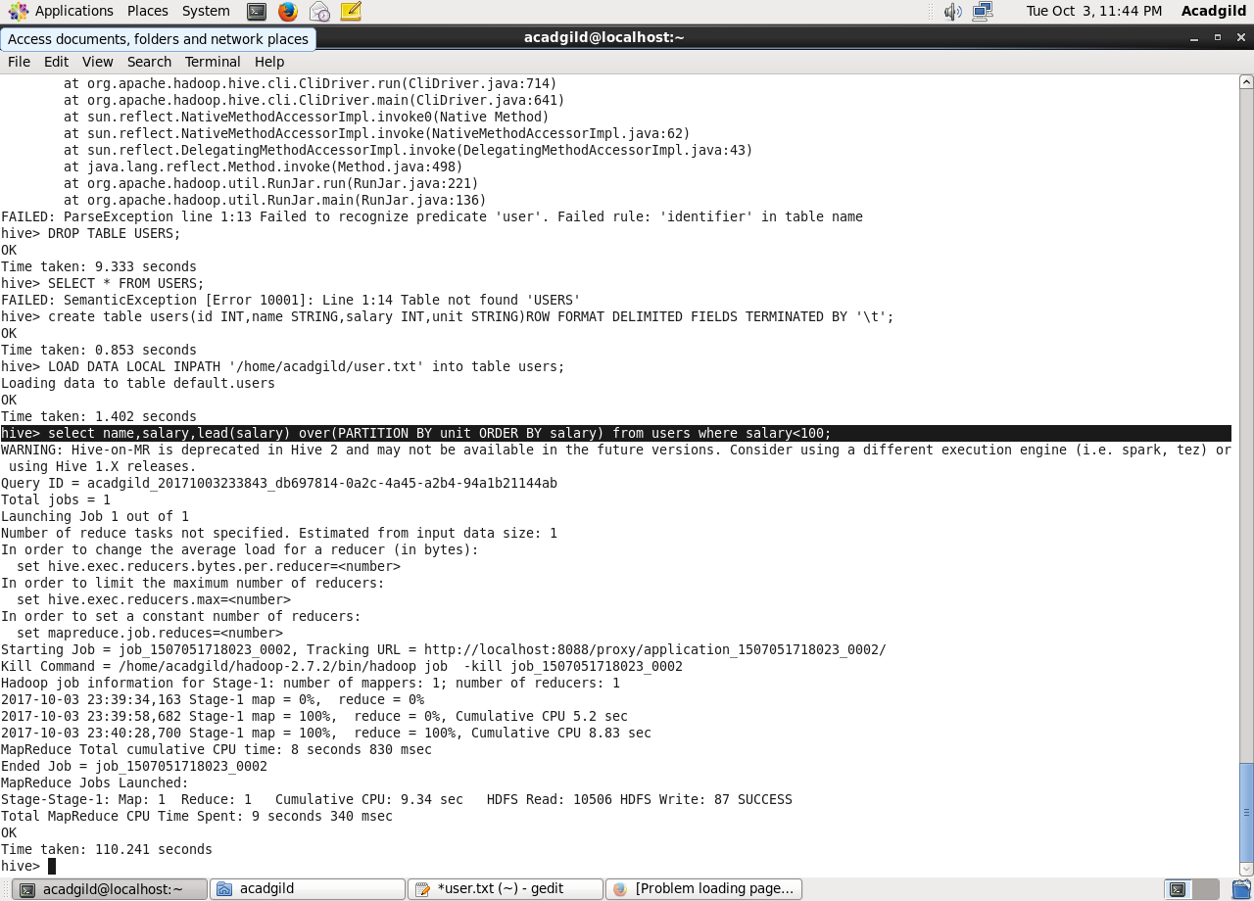

**2. List of all employees who draw higher salary than the average salary of that department**

**Sol:**

SELECT name, salary, rank FROM(

SELECT name, salary, dense_rank() OVER (PARTITION BY unit ORDER BY salary) AS rank

FROM users) temp

WHERE rank > 2;

